RPN Calculator
(Java program done in programming course at Stanislaus State)
Ethan Machado
The RPN calculator uses a stack data structure to compute calculations quickly. This reverse polish notation calculator utilizes multiple Java classes via a constructor to link the RPNCalc class to the Driver class.
The Driver class contains the main method, a constructor to the RPNCalc class, and a do-while loop that runs the program until the user quits.
The RPNCalc class initializes the stack data structure and contains several methods that evaluate user input using the stack’s last-in first-out (LIFO) characteristic.
The StackDemo class contains methods that define the operations that the stack can utilize such as peek and pop that allow the data structure to add and remove records.
Source code:
Driver class:
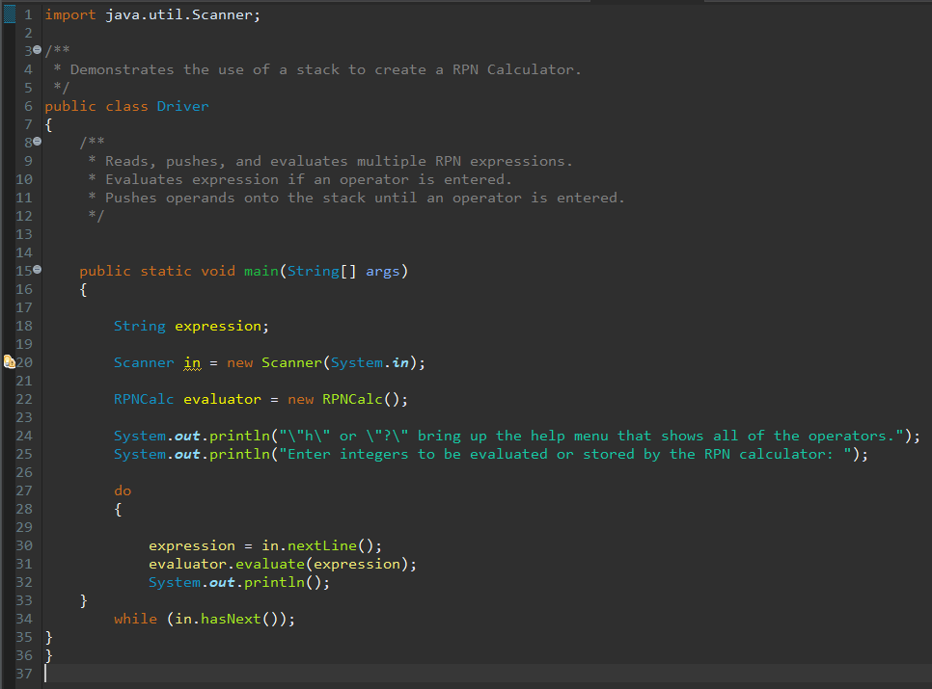

RPNCalc class:
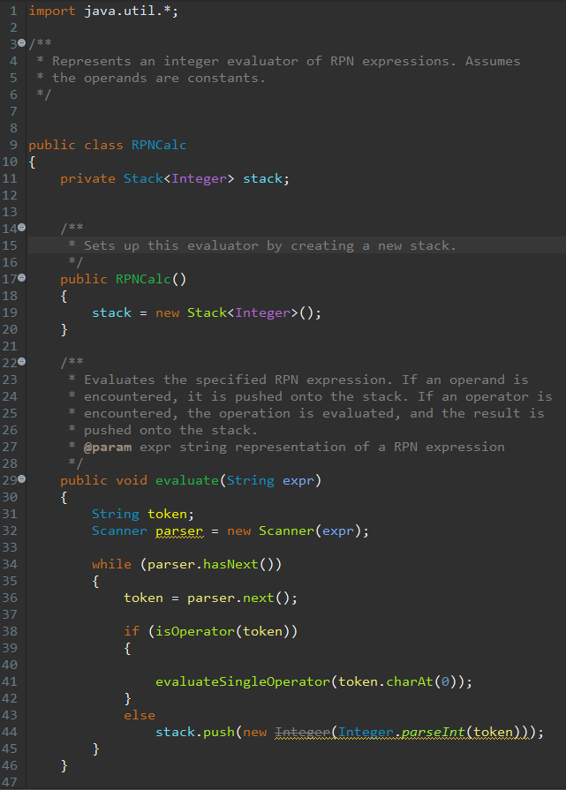
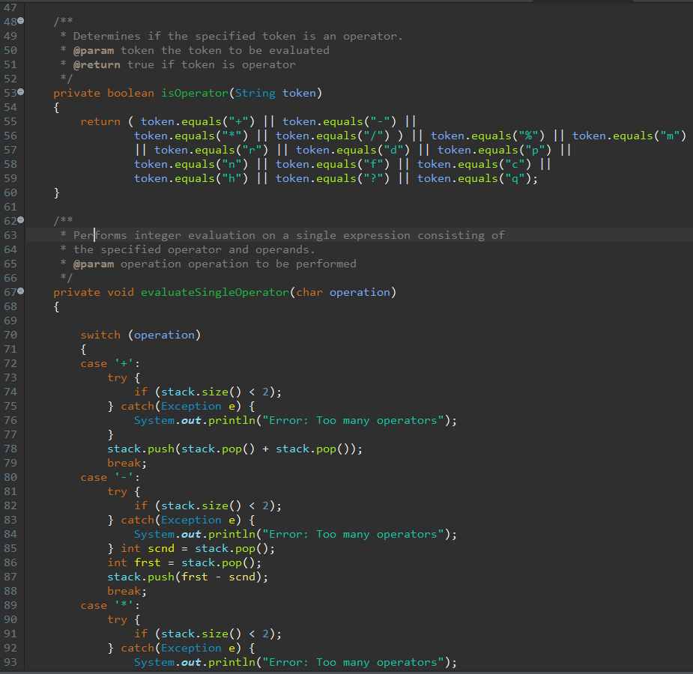
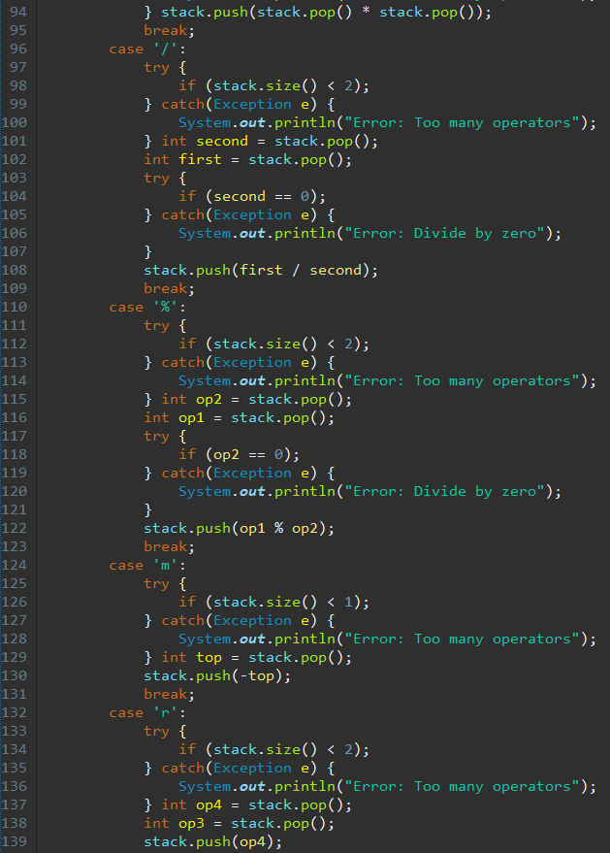
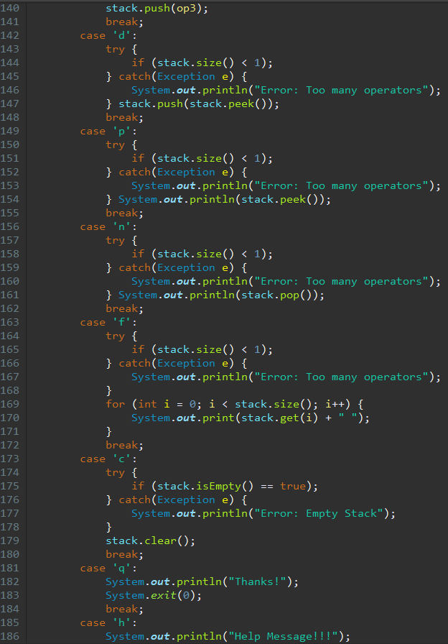
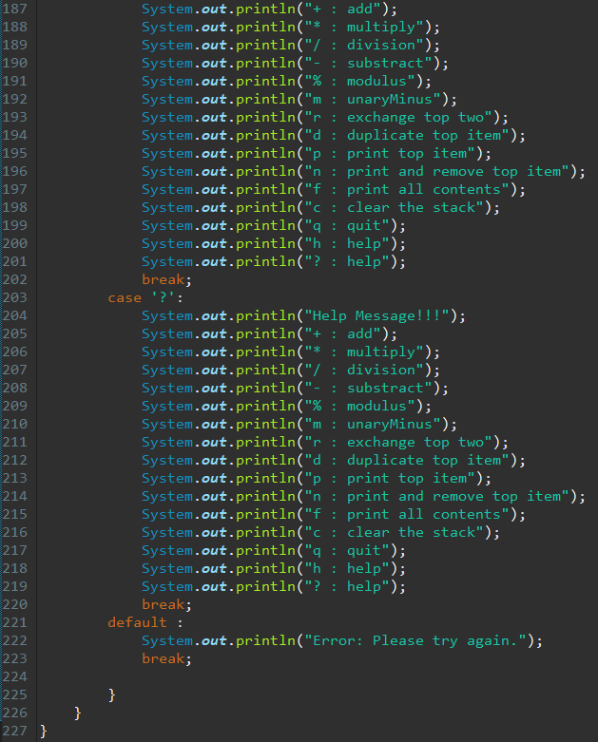

StackDemo class:
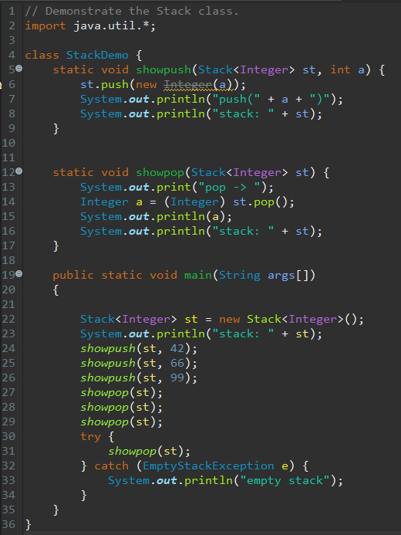

Example of user input and execution:
*Note: Numbers being entered with no characters are being added onto the stack and are waiting for operations to be carried out.
